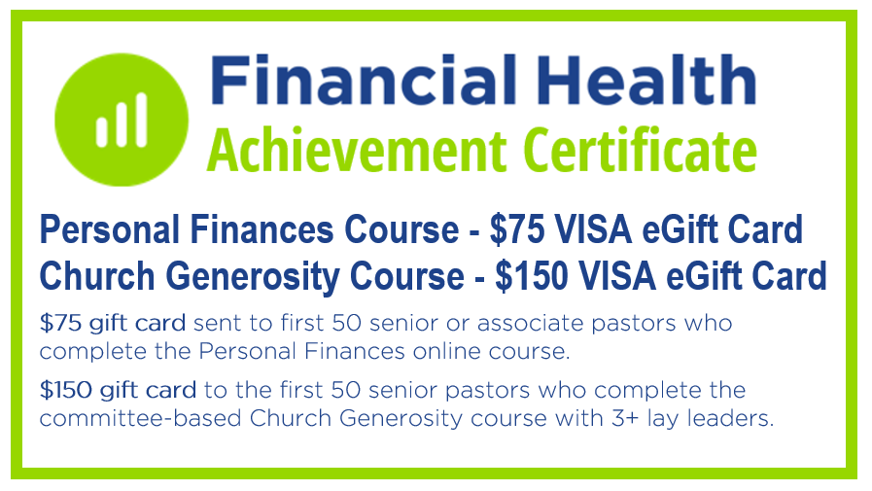
Denomination Name
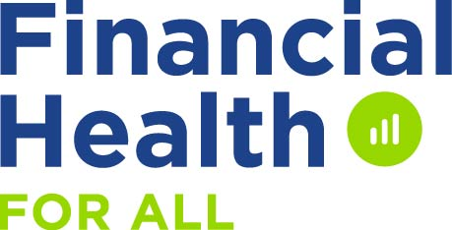

You Are Invited
to participate in free online training
Our denomination has been blessed with grant-funded training resources and eGift cards to benefit our pastors and churches.

Personal Finances Online Course
This free online course was specifically created for pastors/spouses, but any interested church staff, leaders or members will also benefit from this training.

This biblical training will give you the online tools to help you accomplish any of the following:
- Learn from Christian financial experts Increase savings Evaluate your insurance needs
- Increase your income sources Energize your giving Better prepare for retirement
- Track and decrease expenses Set financial goals Experience more of God’s provisions
- Pay off debts Find affordable health care Improve your financial health

There are six 90-minute monthly sessions that can be done at home on your own schedule. If you register for this free course, you will receive a monthly eNewsletter with a link to the monthly online lessons, additional Best Practices resources and a link that will allow you to participate in a free monthly video coaching call.

Personal Finances Course Begins in September (Register Online from April through August)
Go to NAEfinancialhealth.org/xxx to preview the monthly videos/materials and to register for this course. Feel free to share information about this course with others you know in your church or other churches that could benefit from this training.

Church Generosity Online Course
This free online course was specifically created for a pastor and a group of lay leaders (3 or more) to do during regularly scheduled committee meetings. There are six monthly sessions that will take 20-45 minutes to complete depending on the amount of discussion each month. This biblical training will help you and your key leaders determine the best ways to improve the generosity and financial health of the people in your church.

Through the monthly video interactive lessons, you and your leadership team will learn and discuss:
10 Ways People are Influenced to Live Generously 7 Keys to Joyful Giving How Any Church Can Grow Giving

Your team will also learn how to effectively use the following resources:
Generosity devotional Bless Your Pastor brochure Bless Your Church legacy brochure 12-month planning calendar

Church Generosity Course Begins in January (Register Online from April through December)
Go to NAEfinancialhealth.org/??? to preview the monthly videos/materials and to register for this leadership course.

Financial Health Year-Round Website Resources
All of the assessment surveys and Best Practices resources that are included in both courses are freely available anytime once you register at NAEfinancialhealth.org/???. In addition to Personal Finances and Church Generosity resources, there are also Pastor Compensation and Church Finances Best Practices free resources online.

Sign Up Now at NAEfinancialhealth.org/???

