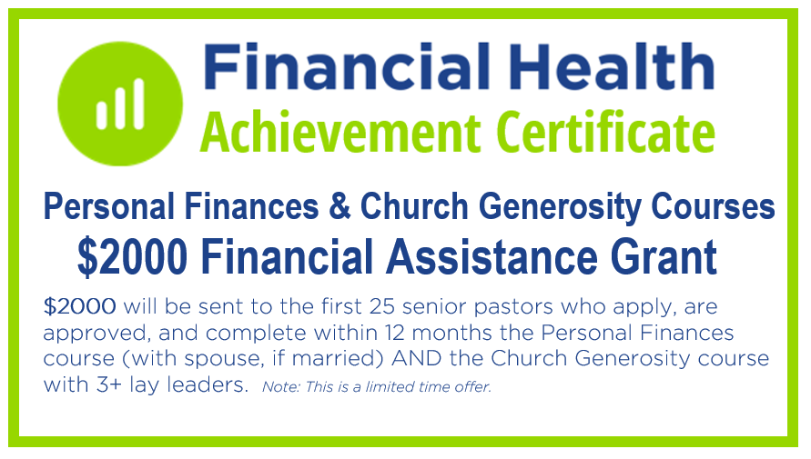Denomination Name

**Senior Pastors:**

**You may be eligible for a $2000 grant**

Our denomination has been blessed with matching grant funds to offer $2000 financial assistance grants to the 25 senior pastors that meet and complete the following criteria:

* [Denominational partners will decide what to say in this section]: Have one or more of the following financial needs:

🞏 Unpaid medical bills greater than $?????) 🞏 Student loans greater than $????)

🞏 Over (???) years old, do not have a personal retirement account, agree to open a denomination retirement account and the church is willing to contribute at least $??? each year from the budget into this account in 2019 or earlier

* Senior Pastor that is credentialed, licensed or ordained in our denomination and over the age of (???)
* Visited [NAEfinancialhealth.org/???](http://www.NAEfinancialhealth.org/) and previewed (with your spouse, if married) the Personal Finances course
* Visited [NAEfinancialhealth.org/???](http://www.NAEfinancialhealth.org/) and previewed the Church Generosity six monthly committee-based lessons
* Chosen and talked with a designated lay leader that has reviewed this application, previewed the online Church Generosity lessons and has agreed to schedule these committee-based interactive lessons for the pastor and 3+ lay leaders.
* Upon receiving approval by our Financial Health Committee in August, you agree to complete the Personal Finances and Church Generosity courses between September 1, 2018 and August 31, 2019. This includes having your lay leaders help schedule the use of a churchwide generosity devotional and Bless Your Pastorbrochure and offering in 2019.
* Turn in (fax/email/mail) before July 31, 2018 this completed form and an IRS W9 form. If you are applying for the retirement financial assistance, please attached the completed form to start a denominational retirement account.

*Note: Senior pastors who receive the $2000 Financial Assistance Grant are not eligible for the online courses $75 and $150 Visa eGift cards.*

How did you first hear about the Financial Health courses and grant? ___________________________________________

Your First Name: _______________________ Last Name: _______________________________ Age: ___________

Church: _________________________________________ Worship Attendance: ______ Church Annual Income: ______

Full Church Address: ________________________________________________________________________________

Full Home Address: _________________________________________________________________________________

Email Address: _____________________________________________________________________________________

Personal Cell Phone/Area code: ___________________________ Church Phone: _____________________ Ext: _____

Spouse’s First Name: ___________________________ Spouse’s Cell Phone: ____________________________________ Spouse’s Email Address:______________________________________________________________________________

Designated Lay Leader’s First Name: ___________________________ Last Name: _____________________

Leadership position at the church: ________________________________ Leader’s Cell Phone: _____________________

Leader’s Email Address: ______________________________________________________________________________

Annual housing/salary from the church: $________ Unpaid medical bills: $_______ Student loans balance: $____________

Any additional household income sources? Please briefly explain source(s) and annual amounts: ______________________

_________________________________________________________________________________________________

**Contact us if you have any questions. Turn in before July 31, 2018 (fax/email/mail) with requested documents to:**

Denomination’s Name - Financial Health Committee - c/o Full Name, Title

Address City, State Zip Phone Fax Email

All applications will be reviewed in August. You will be notified by the end of August if you have been approved.